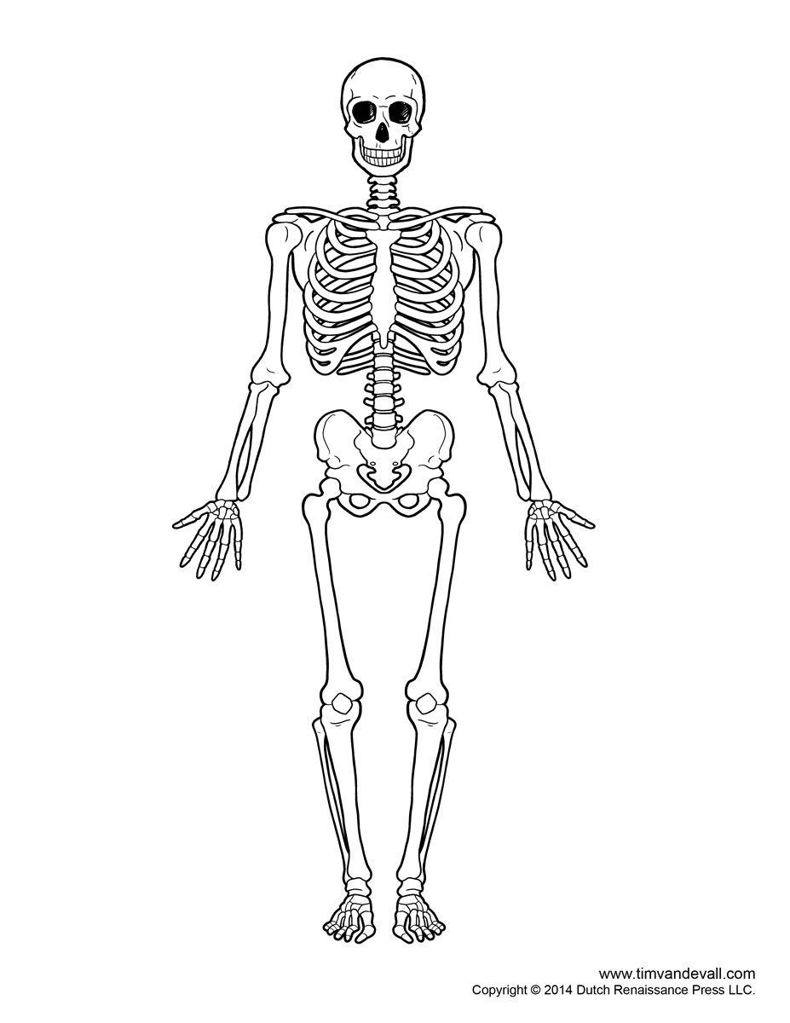
Fitness Study Sheet
Ribs
Clavical
Pelvis
Radius
Humerus
Tibia
Femur
Ulna
Fibula
Skull

Benefits of Regular Physical Activity
    - Increased muscle strength
    - Increase of lean muscle
    - Increase of strength in ligaments and tendons
    - Lower chance of injury
    - Improves self-esteem
    - Can help prevent against diseases and illnesses (eg. Lowers cholesterol, lowers risk of type 2 diabetes)
    - Helps relieve stress
    - Boost energy
    - Improves ability to sleep
    - Improves posture
Importance of Warm-ups & Cool-downs
Warm-up
Purpose: increased circulation, increased body temperature, mental preparation, increased focus on task, prevention of injuries, improved performance
Cool-down:
Purpose: gradual lowering of heart rate, prevention of dizziness/blood pooling, minimized muscle stiffness/soreness
- Health-Related Fitness Components

- Cardiovascular endurance: The ability of the heart, blood vessels and lungs to provide the working muscles with adequate oxygen during prolonged activity.
- Flexibility: The range of motion of a joint.
- Muscular endurance: The ability of a muscle or group of muscles to exert force over an extended period without incurring fatigue.
- Muscular strength: The amount of force that can be exerted by a muscle or group of muscles in a single effort.
- Body composition:

