Spikeball Rules
During Play
- Once the server strikes the ball, players may move anywhere they choose.
- Possession changes when the ball contacts the net. Each team has up to 3 touches per possession
- Determine a serving order which alternates players from the two teams
Scoring
- Games are typically played to 11, 15, or 21 (must be determined before start of game)
- Games must be won by two points
- The rally ends and a point is a point is awarded when:
  - The ball contacts the ground or otherwise isn't returned onto the net within 3 touches.
  - The ball is hit directly into the rim at any time, including on a serve.
  - The ball bounces and falls back onto the net or rim.
  - The ball clearly rolls across the net
Serving
- If the receiving team wins the point, the next designated player serves according to the initial order. Otherwise, the server switches places with his/her partner and serves to the other receiving team member (Keep the same serve)
- Serves may be struck with any amount of force; short serves are allowed.
- Servers get 2 attempts to create a playable serve
- If a server serves two faults, the receiving team wins the point. Violation of ANY of the following rules is a fault:
  - The server must toss the ball upward at least 2 inches.
  - If the server tosses the ball, he/she must hit it. Dropping, catching, or swinging at and missing a toss all count as a fault.
Rallies
- Consecutive touches by one player result in a loss of a point.
- The ball must be contacted cleanly, not caught, lifted, or thrown. Players may not hit the ball with two hands, even if placed together "volleyball style".
- Players may use any individual part of their body to hit the ball.
- After the serve, any unusual bounce (i.e. pocket) that does not contact the rim is legal and playable.
- A shot which lands on the net, rolls into the rim and then off the net (i.e. roll-up) is played as a pocket, not a direct rim hit.
- If teams cannot determine the legality of a hit, replay the point.
Infractions
- Defending players must make an effort not to get in the way the offending team's possession or play on the ball.
- If an offender collides with a defender, or a defender's position prevents an offensive play on the ball, the infracted player may call "hinder" to force a replay of the point.

Rules for people who like pictures
3 Touch
Players have up to three alternating touches to return the ball to the net
2 vs 2
Team 1 serves to Team 2 to start a point

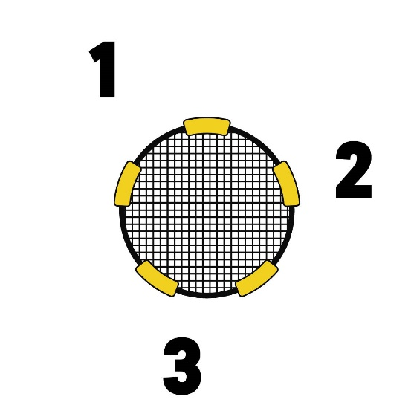
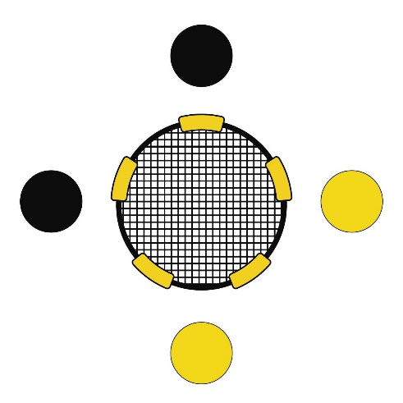
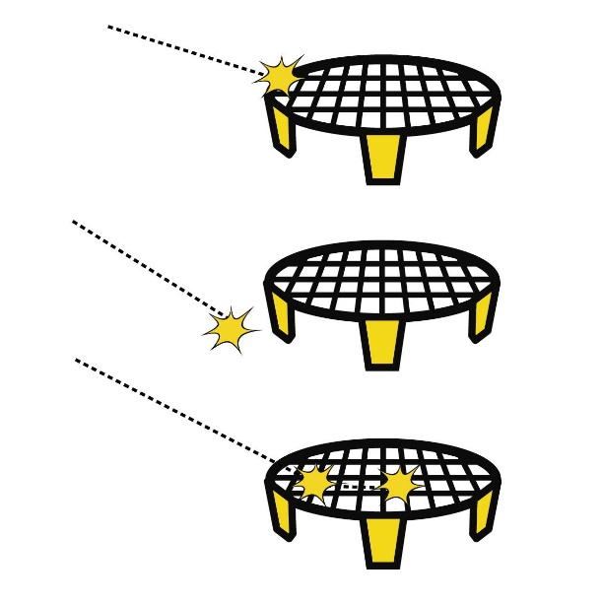
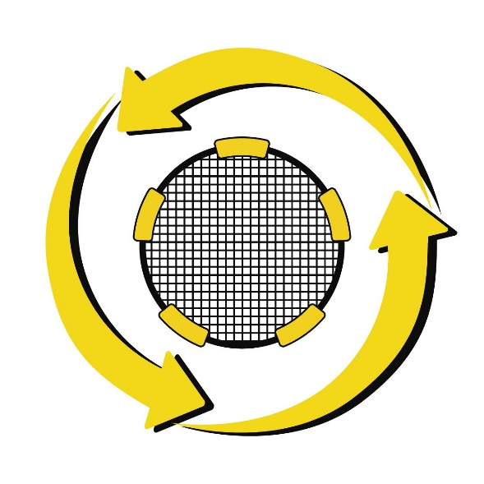
360 Play
After the serve, players can move or hit in any direction
Scoring
Points are scored when the ball hits the rim, the ground, or bounces more than once on the net

