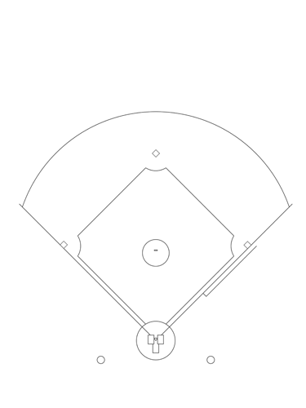
Kickball Study Sheet
2nd base

3rd base
1st base

Home Plate

Objective:
To obtain more points (runs) than the opposing team. The idea is to strategically kick the ball thrown at you towards the field before running around 4 bases to complete a run.
Terms:
Kicker: the player who is kicking the ball
Pitcher: the player who is rolling the ball to the kicker
Pop fly: A high fly ball that can be easily caught
Bunt: A light or gently tap while kicking the ball
Rules:
- In the center of the field is the pitching mound where the pitcher stands and rolls the ball toward the kicker (we use a hula hoop for our mound). The kicker stands at the home plate. The other three bases are known as first base, second base and third base. The kicking player(s) must touch all bases before successfully scoring a run.
- To score, a kicker must kick the ball with their foot into the designated fielding area and make it around all four bases. A player can stop at any base if they feel they might not make it to the next base before being tagged out.
- Each team alternates between kicking and fielding
- The phrase 'the bases are loaded', refers to the instance where there is a player on every base (1,2,3).
- A “foul ball” will result in a strike and the kicker remain at the home plate to kick again.
Ways to get “out” in our PE class
- Catch a pop fly
- Tag the player
- Tag the base the player is running to
- Have possession of the ball while in the pitcher’s hula hoop
- 3 strikes = Out
- Runner/Kicker interferes with the ball

