Touch Football Study Sheet
Object
The object is to score more points than your opponents in the allotted time. In order to do so, they must move the ball down the field (typically in phases) before getting the ball in the endzone for a touchdown. In National Football Association (NFL) teams get 4 chances (known as downs) to move the ball 10 yards forward. Canadian Football Association teams get 3 downs. After the maximum downs are allotted and have failed to make it over the 10 yards required, the ball is then turned over to the opposing/defensive team.
Players/Field
There are 11 players allowed on the field from each team. Players are generally split into three groups
- Attacking (includes positions such as quarterback and receivers)
- Defense (includes positions such as line backs and defensive backs)
- Specialists (responsible for kicking and punting)
A football field is generally around 100 yards long and 160 yards wide. Lines are drawn on the field at 10 yard intervals to help indicate how far each team has to go before reaching the end zone. Each end zone on opposite sides of the field are roughly 20 yards in length. Posts are found at each end as well.
Scoring
6 points is awarded to a team when a player scores a touchdown. A touchdown can occur either from a player receiving a thrown ball or the ball being run into the end zone. After a touchdown has been scored the attacking team will have a conversion opportunity. Here they can gain an additional 1 (kicking the ball between the upright posts) or 2 (getting the ball in the end zone) points.
A field goal can be scored from anywhere on the field (usually done on the final down) and a successful kick will result in 3 points.
A safety is where the defensive team manages to tackle an attacking opponent in their end zone, which results in the defensive team gaining 2 points.
On Field Rules
- The line of scrimmage is an imaginary line that divides the offence and defense at the beginning of play. A snap also known as a “hike” is what starts the play of scrimmage. Once the snap occurs, both the defense and offence can cross path the line of scrimmage.
- After the snap the quarterback may throw the football to one of their players, run with the ball or hand the ball off where another player will run with the ball.
- Any number of players can rush the quarterback but must raise their hand and count to 7 steamboats.
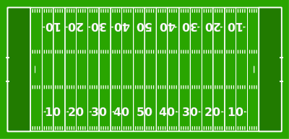
- A down is ended when either (a) a player is ‘tagged’ (b) an incomplete pass is thrown (when a player does not catch the football and it lands on the ground) (c) a player runs out of bounds or (d) a player scores a touchdown.
Running Routes
End zone
Hook
In/Out
Slant
Go

