Badminton Study Sheet
Badminton is a game between two players or a team of doubles hitting a light, feathered shuttle with a racquet over a central net.
Scoring
- The game is played in Rally Point Fashion (side that wins the rally wins the point and next serve)
- The game is played to 21 points and must win by 2 point advantage
Service Rules
- Before the game starts a player is required to hit the shuttle up into the air and see who starts with the serve. This is determined by the direction the shuttle head is facing.
- Both players must stand diagonally opposite service courts without touching the boundary lines.
- The score is the indicator of what side the server serve’s from. If the score is even (0,2,4,6, etc.) then the server starts on the right side of their court, while the odd score (1,3,5,etc.) means they serve on the left side.
- While serving, the shuttle must be hit below the server’s waist with the racquet head below the server’s hand. In addition, the server and receiver must have part of both feet stationary in contact with the ground.
General Play
- Once the shuttle is in play, the point continues with players attempting to hit the shuttle back and forth across the net. A player/team wins the rally either:
  - hitting the shuttle to the floor on the opponent’s side OR
  - the opponent fails to keep the shuttle in play
- If the shuttle lands on a line, it is considered in bounds.
- In singles, if the server wins a rally, the server shall score a point. The server will then serve again from the alternative service court. If the receiver wins a rally, the receiver shall score a point. The receiver then becomes the new server
- In doubles, if the serving side wins a rally, the serving side shall score a point. The server then serves again from the alternative service court, switching with their teammate. If the receiver wins a rally, the receiver shall score a point. The receiver then becomes the new server on the appropriate service court. Teammates only switch during a gain of point on their serve.
A fault is called:
- If a player swings and misses while serving – resulting in the other player/team gaining a point and serve.
- If a player touches the net with either their body or racquet during play.
- If a player hits the shuttle before it crosses the net.
A Let (legitimate cessation of play to allow rally to be replayed) is called:
- The server serves before the receiver is ready
- During play, the shuttle disintegrates and the base completely separates from the rest of the shuttle
- Any unforeseen or accidental situations has occurred

Types of Shots:
Clear – a shot hit deep to the opponents back boundary line. This is a defensive shot.
Drive – A fast and low shot that makes a horizontal flight over the net
Drop – A shot hit softly and with finesse to fall rapidly and close to the net on the opponent’s side
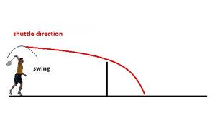
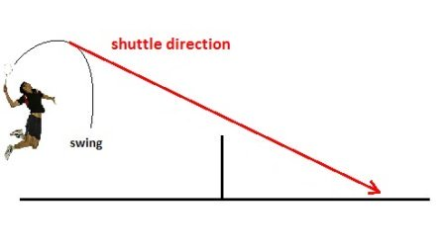
Smash – Hard-hit overhead shot that forces the shuttle sharply downward.
Drop
Smash

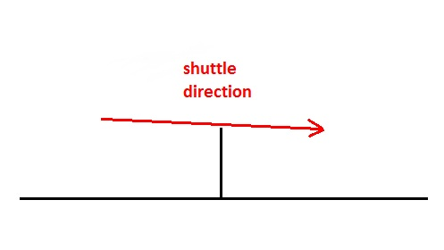
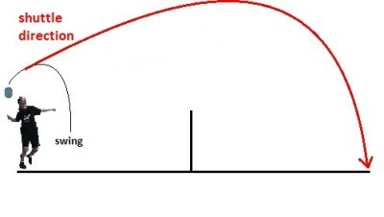
Clear
Drive

Court Lines
